Save the Date

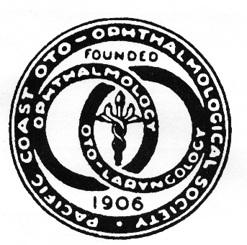

**The 104th annual scientific meeting of the**

**Pacific Coast Oto-Ophthalmological Society**

**June 24-26, 2022**

**Waikiki, Oahu, Hawaii**

***17 AMA* *PRA Category 1 Credit(s)*™**

* **Ophthalmology Updates:**

**Retina, Neuro-Ophthalmology, Cornea, Glaucoma, Pediatrics, Plastics, Uveitis**

* **Otolaryngology Updates:**

**Rhinology, Otology, Head & Neck, Plastics, Endocrine, Laryngology, Pediatrics**

**Outrigger Reef Waikiki Beach Resort**

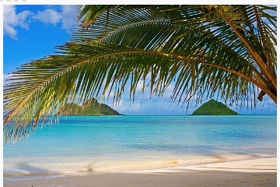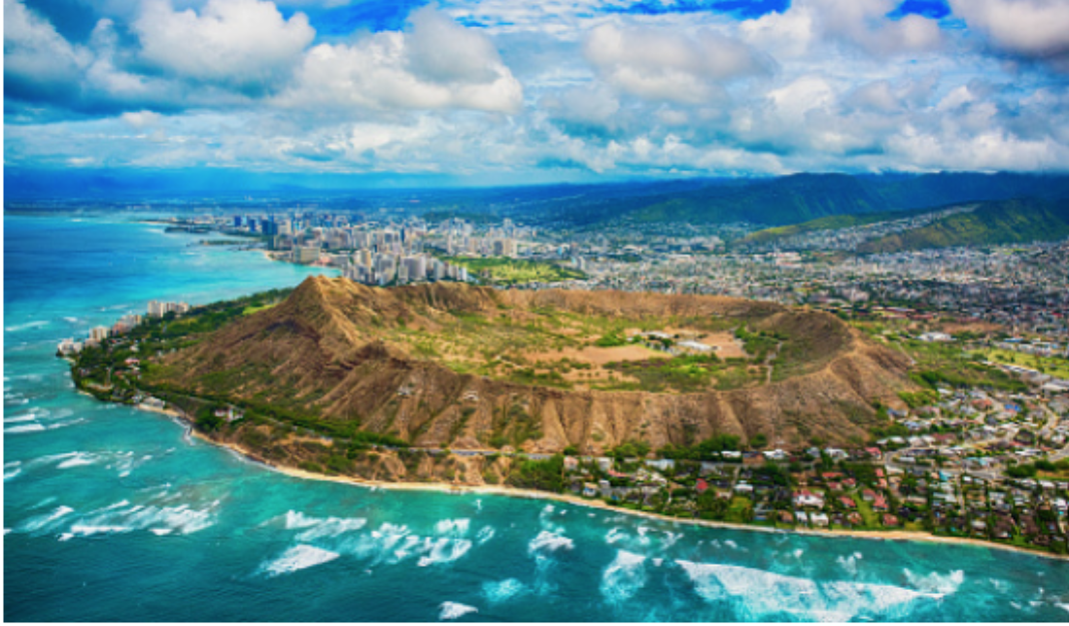 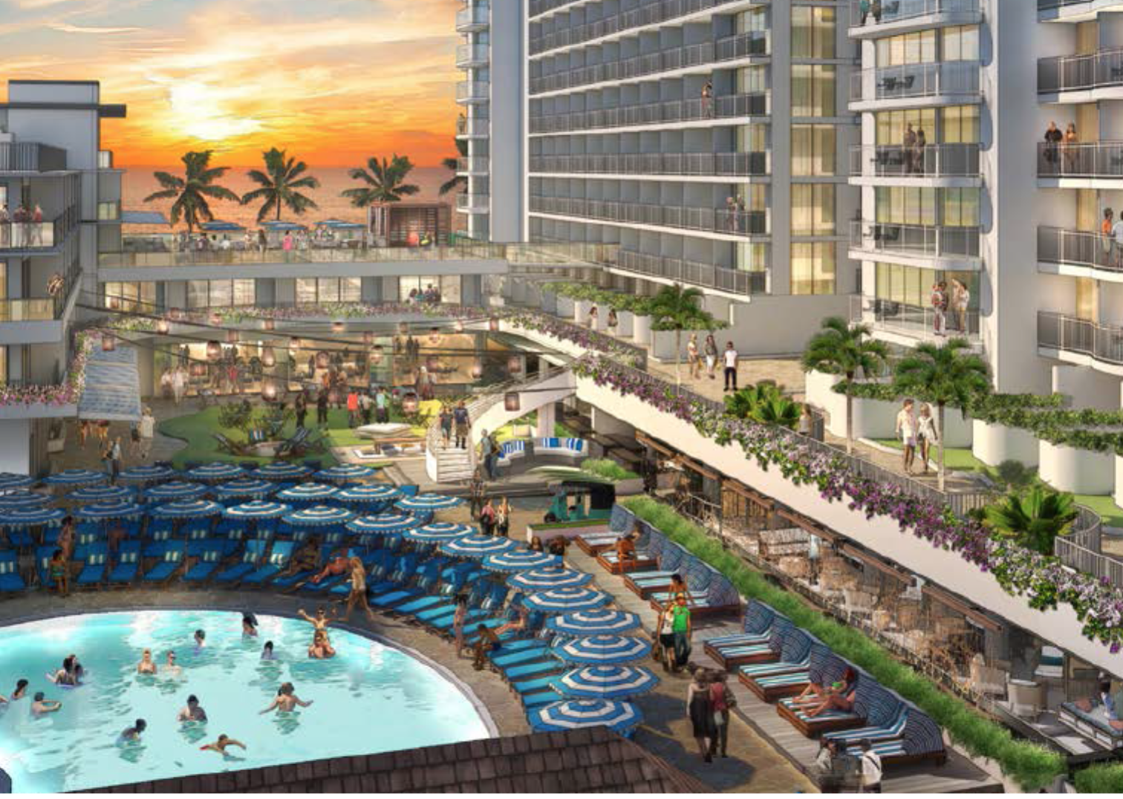

**Information: Thelma deSouza** [**Thelmades@aol.com**](mailto:Thelmades@aol.com) **415-269-0089 WWW.PCOOSonline.org**

Abstract submission deadline 01/31/22 Early Discount Registration deadline 02/28/22